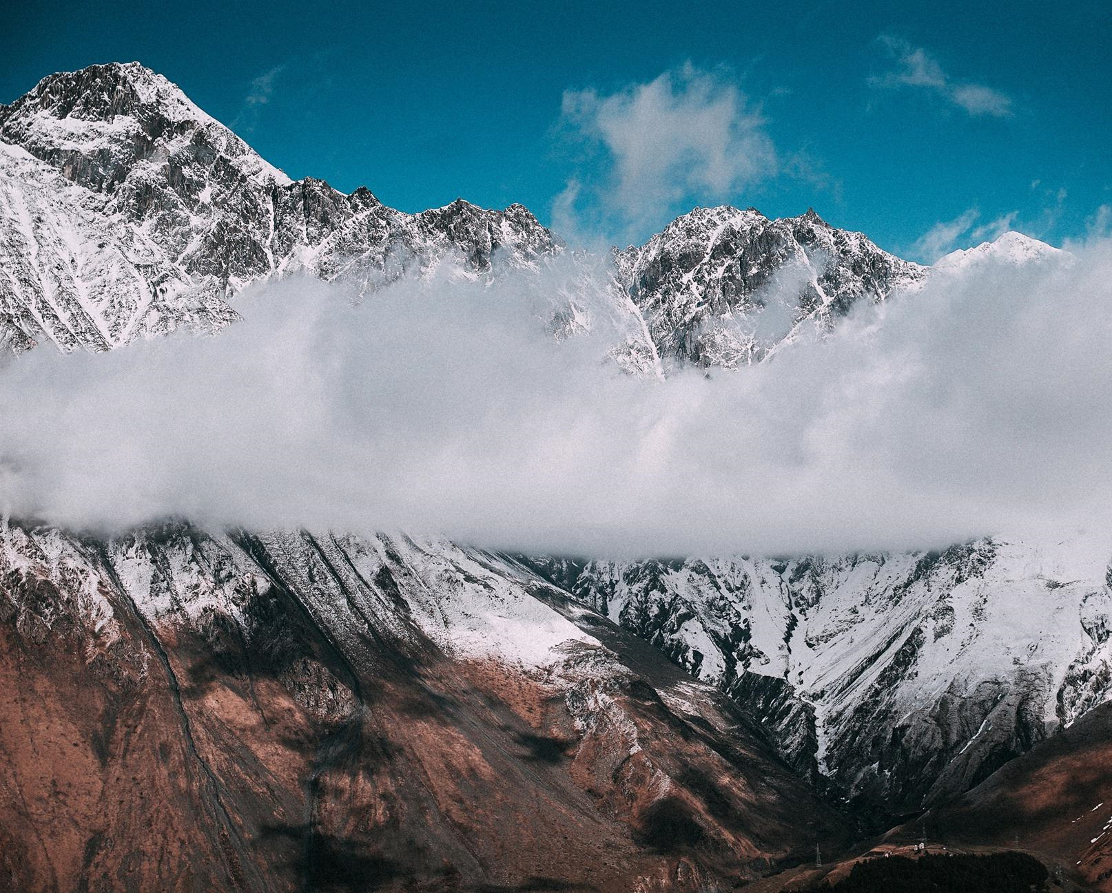

**Day 0: Tbilisi city tour** Breakfast at the hotel. along the Georgian Military Highway towards Kazbegi region. On the way we will drive across the Cross Pass (2 395m.) and along the Tergi River that brings us to Kazbegi – main town in this region. From the centre of Kazbegi drive by 4x4 through beautiful valleys and woodland leads us to Gergeti Holy Trinity church (14th century), stunningly located on a hilltop (2170 m.)

**Day 1: Tbilisi city tour** Breakfast at the hotel. along the Georgian Military Highway towards Kazbegi region. On the way we will drive across the Cross Pass (2 395m.) and along the Tergi River that brings us to Kazbegi – main town in this region. From the centre of Kazbegi drive by 4x4 through beautiful valleys and woodland leads us to Gergeti Holy Trinity church (14th century), stunningly located on a hilltop (2170 m.)

**Day 2: Tbilisi city tour** Breakfast at the hotel. along the Georgian Military Highway towards Kazbegi region. On the way we will drive across the Cross Pass (2 395m.) and along the Tergi River that brings us to Kazbegi – main town in this region. From the centre of Kazbegi drive by 4x4 through beautiful valleys and woodland leads us to Gergeti Holy Trinity church (14th century), stunningly located on a hilltop (2170 m.)

**Day 3: Tbilisi city tour** Breakfast at the hotel. along the Georgian Military Highway towards Kazbegi region. On the way we will drive across the Cross Pass (2 395m.) and along the Tergi River that brings us to Kazbegi – main town in this region. From the centre of Kazbegi drive by 4x4 through beautiful valleys and woodland leads us to Gergeti Holy Trinity church (14th century), stunningly located on a hilltop (2170 m.)

**Day 4: Tbilisi city tour** Breakfast at the hotel. along the Georgian Military Highway towards Kazbegi region. On the way we will drive across the Cross Pass (2 395m.) and along the Tergi River that brings us to Kazbegi – main town in this region. From the centre of Kazbegi drive by 4x4 through beautiful valleys and woodland leads us to Gergeti Holy Trinity church (14th century), stunningly located on a hilltop (2170 m.)

END OF SERVICE



**Land Cost**

blueline.png

**TOUR PACKAGE PRICE PER PERSON BASED ON DOUBLE ROOM OCCUPANCY IN EURO**

|  |
| --- |
|  |
|  | **PAX** | **Editable** | **Editable** |
|  |  | **30+1** |  |

|  |
| --- |
|  |
|  | Private Airport transfers  Transportation according to the tour program | Flight tickets  Insurance  Tips and other personal expenses  Alcoholic beverages  Entrance fees not mentioned in the program |

**Hotels**

blueline.png

**Tbilisi - Hotel Laerton 4\*** (www.laerton-hotel.ge) or the same category

**Further information :**

blueline.png

**Please note the following useful data:**

-Sun and rain protection: Sunscreen, hat, raincoat and wind jacket, comfortable shoes for some sightseeing points

-The ladies will need the headscarf while entering the Georgian Orthodox Churches

-In some churches, the ladies will need the skirt. However, you can find them at the entrance of the church

-The short trousers are not allowed to enter the churches

